Chef Compliance

1. Added Ubuntu node to Compliance server

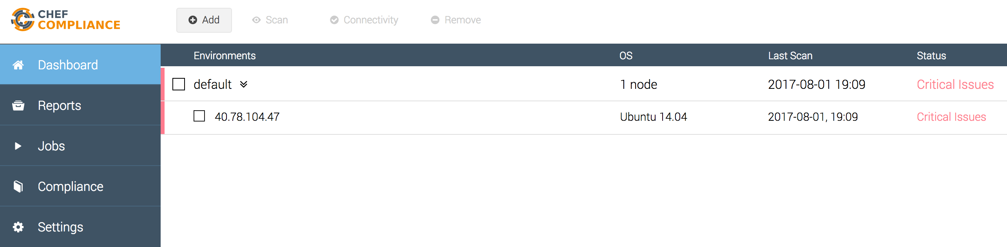

1. Node scanned for CIS (Ubuntu level 1) profile for compliance

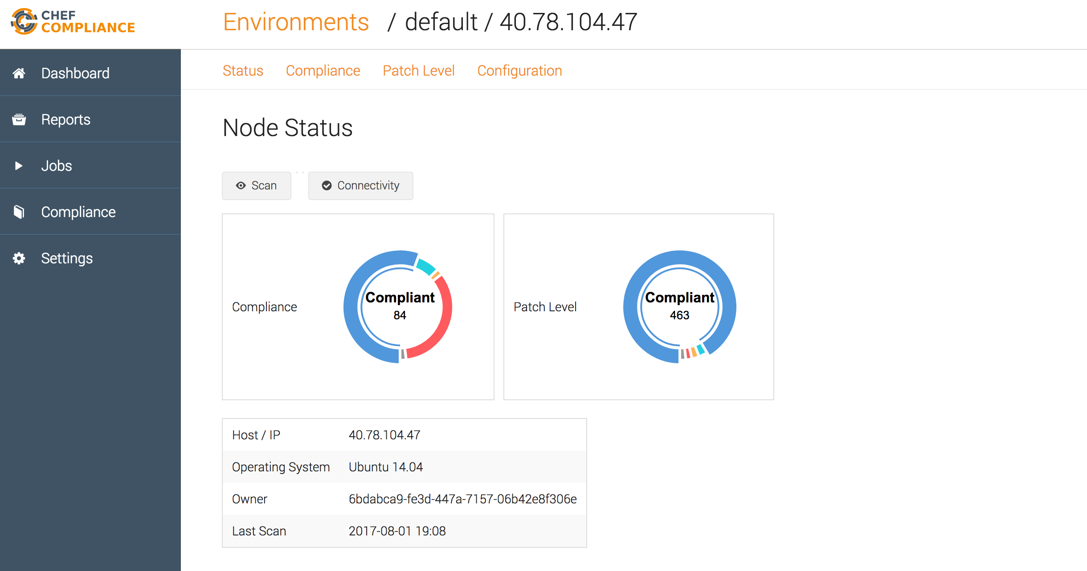

Below image shows 50 critical issues

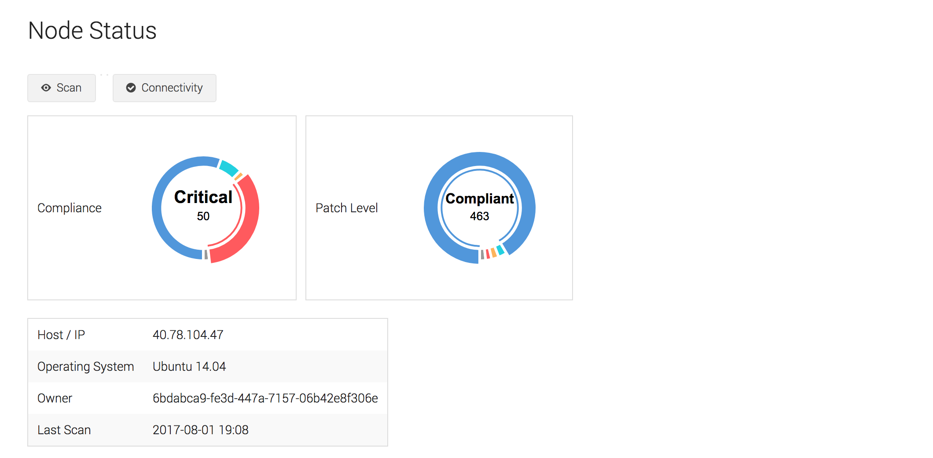

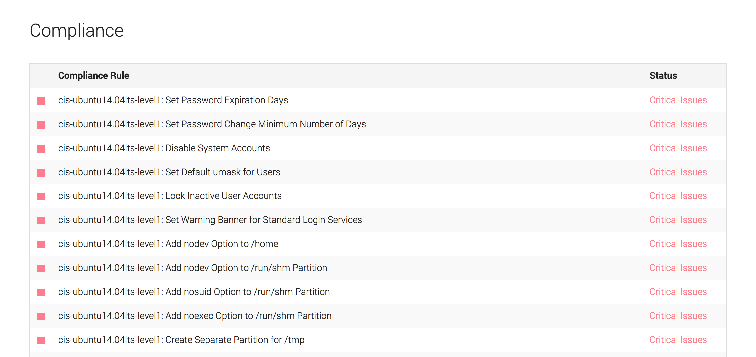

Inorder to fix the first issue “Set password Expiration Days”, run a recipe (cookbook) which updates the /etc/login.defs file on Ubuntu machine with “PASS_MAX_DAYS” & “PASS_MIN_DAYS”

After you run the cookbook, go to compliance server and run the scan again on the node.

Once the one of the issue has been fix (Set Password Expiration Days” the critical issues have been reduced by one

